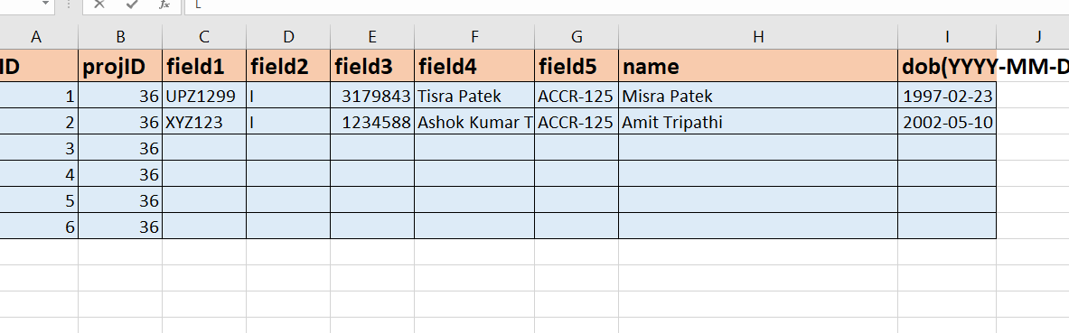

sql query
//sql query
//SELECT *
//0pFROM Institute i
//JOIN Intitute_Accreditation_Detail d ON i.ID = d.Institute_ID
//WHERE i.State_ID = 28
//AND d.Course_ID = 1
//AND d.Accreditation_Status_ID IN(5, 6, 7)
//AND d.Temp_Blocked = 0
//AND(d.BlockedFromDate >= GETDATE() OR d.BlockedFromDate IS NULL)
//ORDER BY i.Name

- Add a new method to check whether accinstituepresentincenters
And ye jobhi selected value hai in DDL_accenter , usko check kare if it exists in table projSubCentere and projMaincenter

Start from the acc_value

- Project subcenter
- Aff insttitue linkaghe
- Then projectmaincenter linkage
- Then nielitcentre linkage

MAM INSTRUCTIONS:
projSubCenteres -> Aff-institutes
projMainCentres -> NeilitCentres

